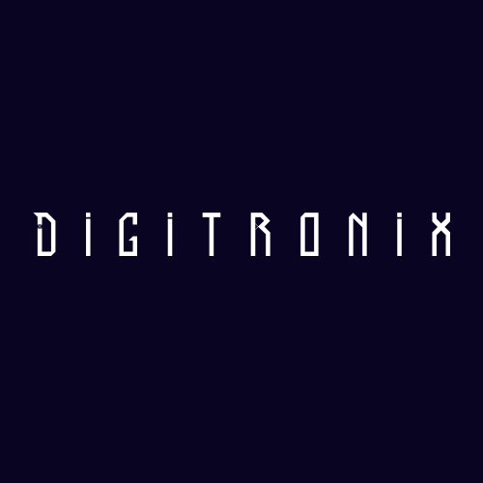
Digitronix

Contents

Assignment 2
Team 2
Stages of development 3
Project description 4
Functions 6

Assignment
The topic is: "Minesweeper Game". We had to create a Minesweeper Game written in C++. The task had to be completed from 17.11.2025 to 08.12.2025. We had to form a team, distribute our roles and everyone’s tasks and make a finished product, which you can read more about in the next sections.

Our Team:

№ | Name and class | Role
№1 | Rafail Kolibarov 9- V | Scrum trainer
№2 | Radoslav Stoyanov – 9 A | Front-end developer
№3 | Selin Vatansever – 9 B | Designer

Stages of development

№ | Stage
1 | Assembling the team  We gathered and distributed the roles, so each person can work on the field that he is most competent with.
2 | Idea  We decided to make a minesweeper game platform. We started thinking of an idea for it, and decided on making the game with different levels, and more.
3 | The process of creating the product  Every week there were meetings to discusses the progress and the tasks that are left. We assigned each task to the person that we believed can do it quickly, clearly, and accurately, so the team would be more productive and efficient.
4 | Polishing the product  After we finished with the project and the documentation, we fixed some bugs and made the overall user experience a bit more pleasant.
5 | Presenting the product  After weeks of hard working and restless nights we finished the project and it is now ready to be presented.
Project description

№ | Description
1 | A general idea about the projetc  The general idea of our project is a minesweeper game with different levels of difficulty, timers recording your time, etc., where you can have fun exploring the maze of the C++ complier!
2 | How to access our project  Our repository: https://github.com/codingburgas/sprint-math-games-9th-grade-digitronix/tree/main If you want to install our platform, you can navigate towards the "Release" tab in GitHub and download the latest version.  To download our project past the following code in your CMD:  git clone https://github.com/codingburgas/sprint-math-games-9th-grade-digitronix/tree/main
3 | Team work  The main communication platform we used is Teams. During the project we stayed in touch with each other.
4 | Used technologies for our project development  The platform is written in C++. We used GitHub for collaborative work. We used Canva for our visual elements. For the documentation and presentation we used Microsoft Word &Microsoft PowerPoint.

